XVIIth colloquium of the French Group of Bioelectrochemistry
XVIIème colloque du Groupe Français de Bioélectrochimie
Saint-Dié-des-Vosges, January 31st- February 3rd 2022
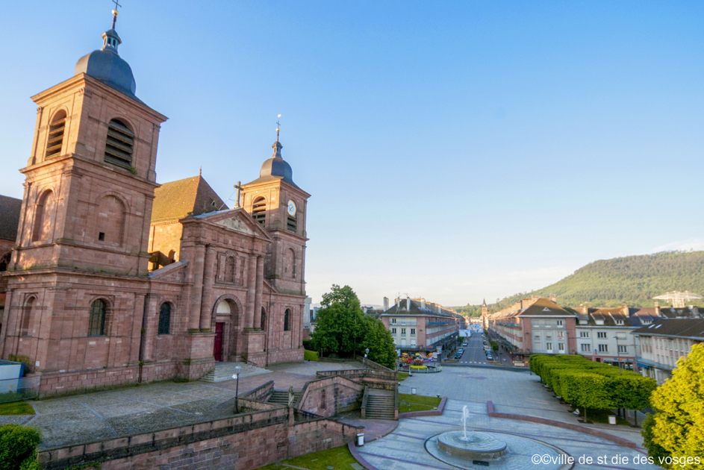
Communication information :

Person: Mrs ◻, Ms ◻, Mr ◻
Family Name:
First Name:
Laboratory:
University / Company:
Address:
e-mail:
Tel:

Abstract title:

Authors :

Type of communication :
Oral - talk ◻
Poster /Flash Com’ ◻
No choice ◻
Interest to participate in a Special Issue of Bioelectrochemistry:
Would like to be considered ◻

Limit of submission: December 1st, 2021
Send your abstract and form to: gfbioelectrochimie@gmail.com
Please use the abstract guideline below:
TiTLE
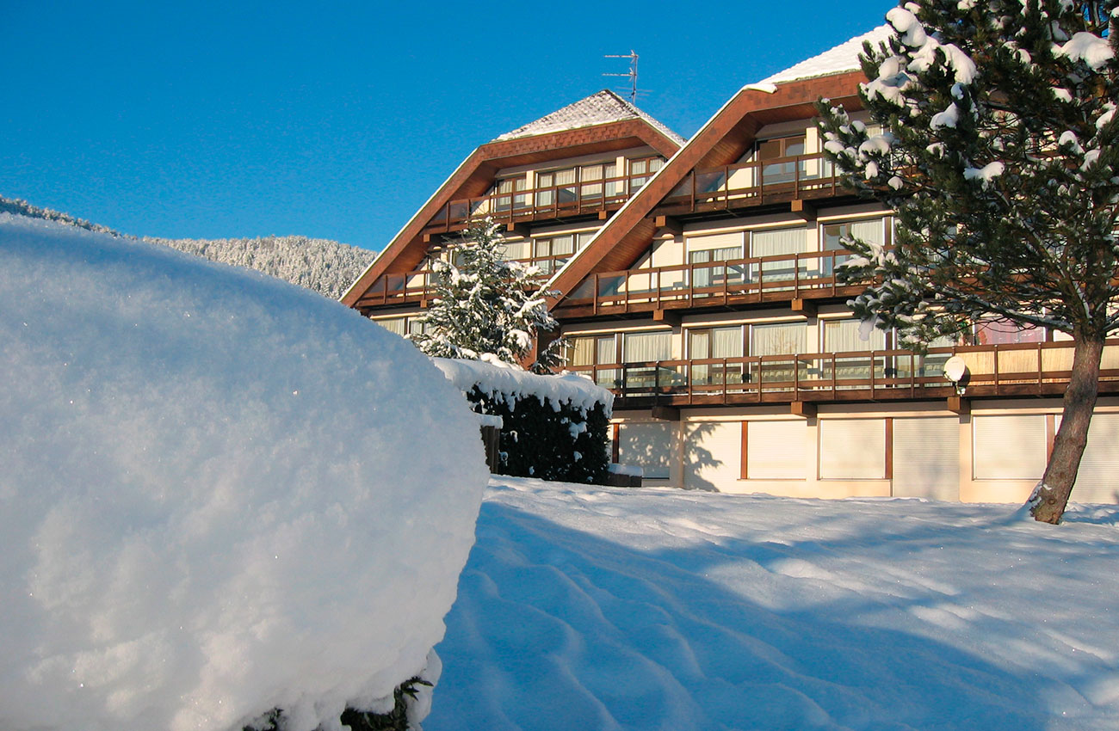

X.Y.X. Name ^{1,2}, X.Y.X. Name, ^{1,2} X.Y.X. Name ¹, …

¹ First Affiliation
² Second Affiliation

email@domain.fr

First paragraph.
Second paragraph

XXX
Caption of a figure, if any

References

