XVIIth colloquium of the French Group of Bioelectrochemistry
XVIIème colloque du Groupe Français de Bioélectrochimie
Saint-Dié-des-Vosges, September 26th- 29th 2022

Location : La Bolle (Village CAP France)
34 Chemin du Réservoir, 88100 Saint-Dié-des-Vosges, France : https://la-bolle.fr/

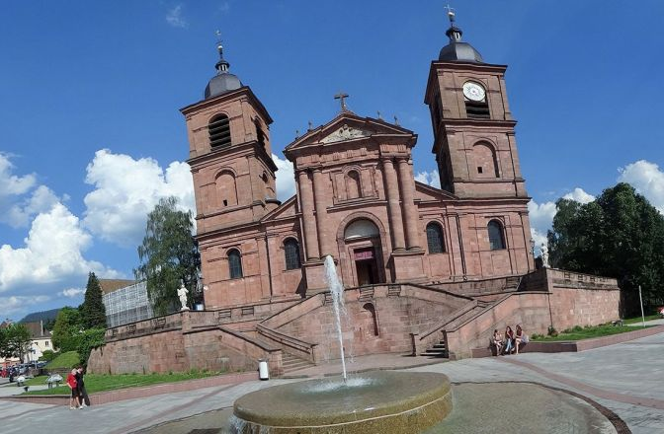 | 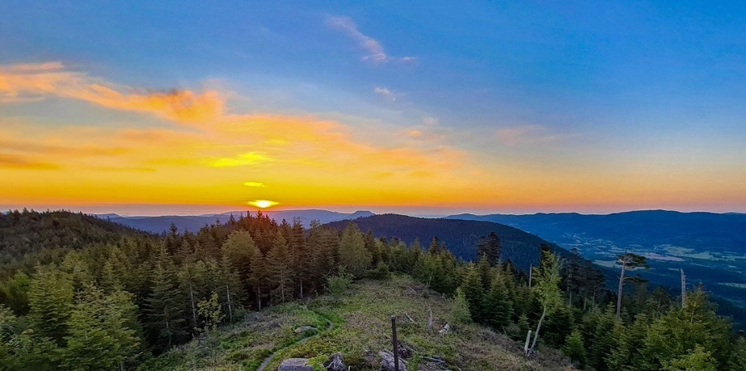
Conference Program:
Arrival and check in: Monday, September 26th 2022, afternoon; conferences start at 4:00 pm
Departure: Thursday, September 29th 2022, after lunch (2:00pm)

Themes :
- Modified Biosensors and Electrodes
- Biofilms and Biocorrosion
- Biofuel cells
- Development of biochips and integrated systems
- Proteins Electrochemistry and Biomimetism
- Electrochemistry of Cells and Tissues

Invited Speakers :
Cecilia Cristea (Univ. Cluj-Napoca, Rumania)
Frederic Gloaguen (Univ. Bretagne Occidentale, France)
Christel Laberty-Robert (UPMC, Collège de France, France)
Fred Lisdat (TUAS Wildau, Germany)
Vincent Noël (Univ. Paris Cité, France)
Sophie Sacquin-Mora (Univ. Paris Cité, France)
Sabine Szunerits (Univ. Lille, France)

Organizing Committee :
Mathieu Etienne (Univ. Lorraine), Grégoire Herzog (Univ. Lorraine), Benoit Piro (Univ. Paris Diderot), Stéphane Arbault (Univ. Bordeaux), Florence Lagarde (ISA-Lyon), Fabien Giroud (Univ. Grenoble Alpes)

Deadlines
Abstract submission: May 25th, 2022
Registration: June 30th, 2022
https://www.bioelectrochimie.fr/

XVIIth colloquium of the French Group of Bioelectrochemistry
XVIIème colloque du Groupe Français de Bioélectrochimie
Saint-Dié-des-Vosges, September 26th- 29th 2022

Communication information:

Person: Mrs , Ms , Mr
Family Name:
First Name:
Laboratory:
University / Company:
Address:
e-mail:
Tel:

Abstract title:

Authors :

Type of communication:
Oral - talk
Poster /Flash Com’
No choice

Interest to submit a manuscript to a Special Issue of Bioelectrochemistry: Would like to be considered

Limit of submission: May 25th, 2022
Send your abstract and form to: gfbioelectrochimie@gmail.com
Please use the abstract guideline below:
TiTLE

X.Y.X. Name ^{1,2}, X.Y.X. Name, ^{1,2} X.Y.X. Name ¹, …

¹ First Affiliation
² Second Affiliation

email@domain.fr

First paragraph.
Second paragraph

XXX
Caption of a figure, if any

References

