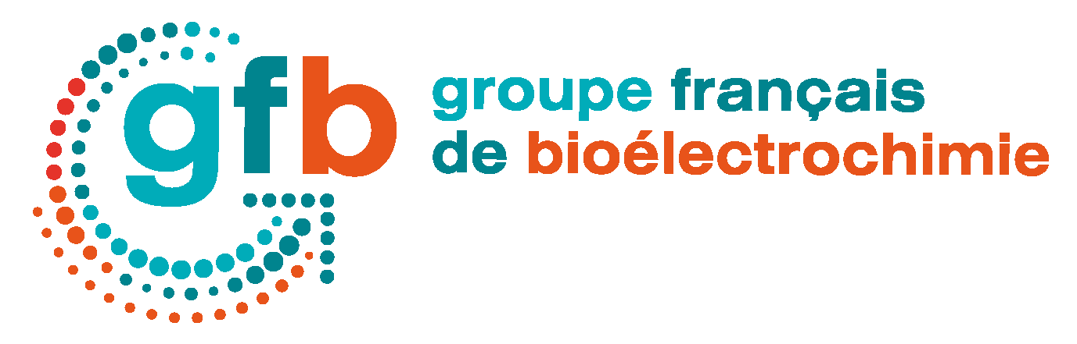
XVIIth colloquium of the French Group of Bioelectrochemistry
XVIIème colloque du Groupe Français de Bioélectrochimie
Saint-Dié-des-Vosges, September 26th - 29th 2022

Location:
La Bolle (Village CAP France), 34 Chemin du Réservoir, 88100 Saint-Dié-des-Vosges
https://la-bolle.fr/

Registration:

The registration fee includes participation in the conference, full board accommodation from September 26th to 29th (3 nights, 6 meals) and the hiking excursion (weather permitting).

- Senior rate or single room accommodation 500 €

- Junior rate (PhD student, post doc) in double room 360 €

- Companies ..................................................………………. (please contact us)
Remark: Any registration received after June 30th 2022 will be increased by 100 €.
Registration deadline: June 30th 2022
Contact:

. Name:
. First name:
. Affiliation:
. Laboratory:
. Address:
. City:
. E-mail:
Please send this registration form at: gfbioelectrochimie@gmail.com

Payment:

- Bank Transfer:
Crédit Agricole du Languedoc
Code banque : 13506 ; Code guichet : 10000
Account n° : 19114478000 ;
International account N°(IBAN :) FR76 1350 6100 19 1144 7800 080
Bank Identification Code (BIC): AGRIFRPP835

- Order form (CNRS) : Please ensure that the payment deadline is met.

Please forward your payments to the GFB Treasurer:
Pr. Benoit PIRO, trésorier du GFB, 141 rue Marcel Hartmann, 94200 Ivry-sur-Seine

